The goal of the project was to determine whether or not we could find a connection between the facilities at a ski resort and ticket prices, and if so could we determine an adjusted ticket price for Big Mountain Ski Resort that matched the market value of its facilities.

I was given ski data that incorporated data from all our market share competitors, and from this data I created a model, which can predict ticket price. The model suggests, assuming our competitor resorts set their prices according to what the market supports, that we are undervaluing our facilities. Big Mountain Resort’s modelled price is $95.87, which is a big difference from its original $81.00 per ticket. If we take in the possibility of error through a mean absolute error of $10.39, we are still left with room for an increase in our ticket price.

The most important features (facilities) that came up during the modeling process were vertical drop, snow making capability in acres, number of total chair lifts, number of fast quads, number of runs, the longest run in miles, number of trams, and skiable terrain in acres. These features accounted for most of the variability in ticket prices amongst the resorts. Other than trams, which the vast majority of resorts had none, Big Mountain was well above the average and even part of the top resorts for most of these features.

The usefulness of the model resides with its ability to determine what facilities the ski customers, i.e. market, see as facilities they would pay more or less for. Of course, a resort can set the price to whatever the resort wants it to be, but the beauty of this model is that it provides a framework for a market price based on the value of its facilities. Thus, through adjusting different features in the model, we can explore various scenarios through which we can either cut costs or increase revenue.

Management has suggested four options they believe can impact our revenue and also cut costs. I have listed these options below:

1. Permanently closing down up to 10 of the least used runs.
2. Increase the vertical drop by adding a run to a point 150 feet lower down but requiring the installation of an additional chair lift to bring skiers back up, without additional snow making coverage
3. Same as number 2, but adding 2 acres of snow making cover
4. Increase the longest run by 0.2 mile to boast 3.5 miles length, requiring an additional snow making coverage of 4 acres

I have explored each of these options by plugging them into our model. The modelled scenarios take into consideration that our expected annual number of visitors is 350,000, and that on average, visitors ski for five days.

First of all, based on the model’s results, pursuing options 3 and 4 would make no difference on the ticket price. I would not put resources into adding more acres of snow making coverage or increasing the longest run by .2 miles.

The most promising option for increasing revenue is option 2. Adoption of the additional facilities in option 2, support an increase in ticket price of $1.99. Thus, the projected annual revenue increase is $3,474,638. Of course, we must factor in the costs of installing the additional chair lift and increasing the vertical drop by 150 feet. Given that the last chair lift installed cost $1,540,000, the projected additional revenue would more than cover the cost of installing another chair lift. I would need more information on the expense of increasing the vertical drop to offer a more accurate picture of expected profits, but regardless, the additional revenue over the years would more than offset any of these upfront expenses.

And lastly a way to reduce operating costs is to pursue option 1; however, this could reduce a market supported ticket price. The drop in ticket price depends on the number of runs closed. The figure below shows a plot of ticket price and a plot of revenue changes based on the number of runs closed.

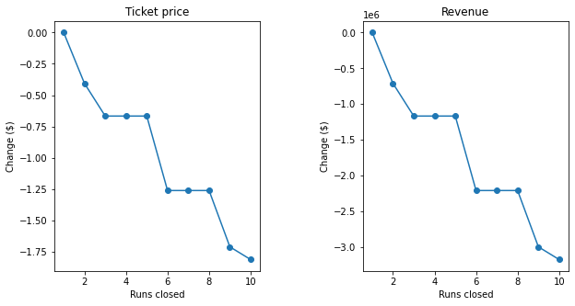

The figure reveals that we can close one run without any consequences on revenue. If we decide to close 2-3 runs, we will see a drop in ticket price, and at that point we might as well close 4 to 5 runs because it will not have a negative effect on price. We see a drop again at 6 and then at 8 and 10 runs. In order to draw a conclusion on what steps to take based on this data, I would need information on the operating costs of maintaining these runs in order to know whether it is worth the loss of revenue in pursuing the strategy of closing the 10 least used runs. With that being said, we can still reduce a portion of our operating costs without seeing any adverse effects on revenue by closing only one of the runs.